- Create class Person (Data Member- name, phone). Create two member inner classes Address (Data Member- House_No, Street, City, State; Method- displayAddr()) and DateOfBirth (Data Member- Day, Month,Year; Method- displayDOB()). Display() is the method of Person class which will display name, address and date of birth of a Person object.
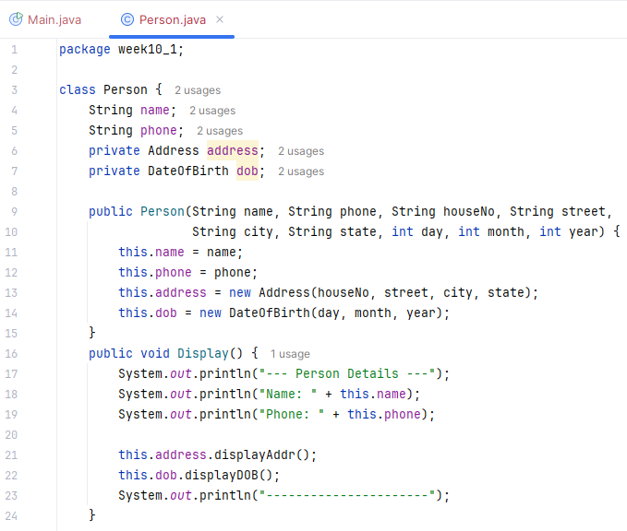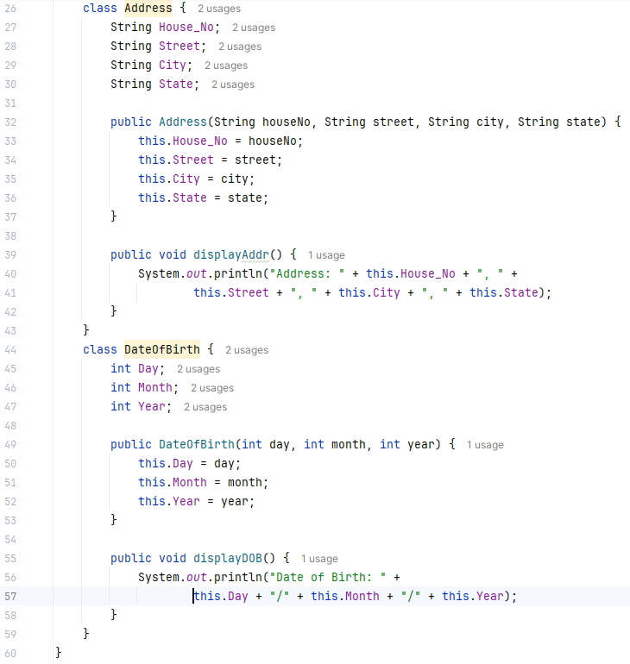
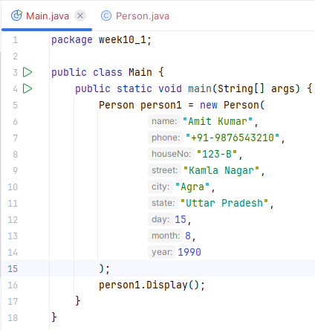
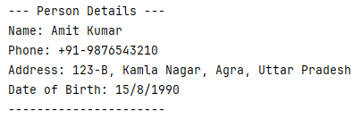
- Create class Edible. Within that define two static classes Fruit and Vegetable. Fruit class will have two methods- fruitDetails() is a static method and fruitPackaging() is a non-static method. Vegetable class also has similar methods - vegetableDetails() and vegetablePackaging(). Call all the four methods from main method.
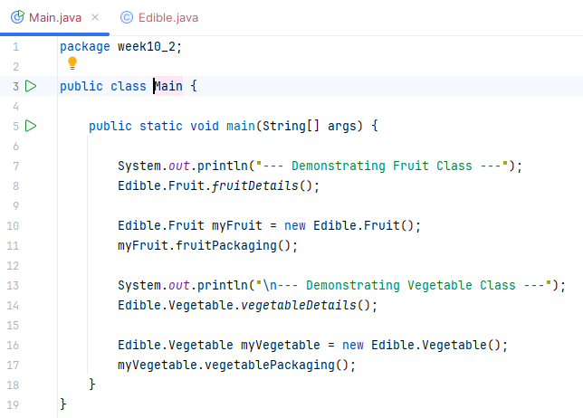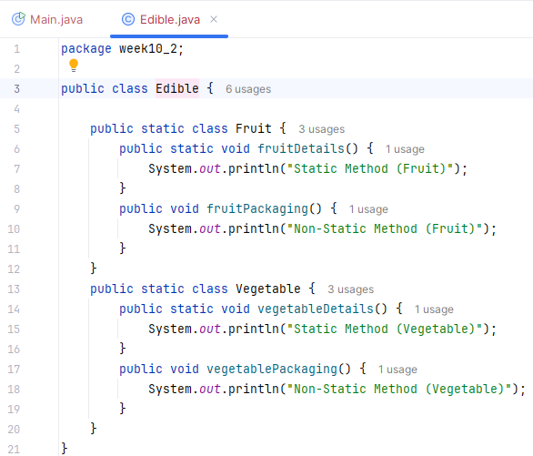
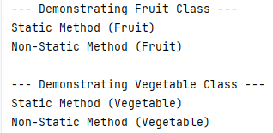
- Create three different minMaxAdd() methods to calculate minimum, maximum and addition of integers, real numbers and characters.
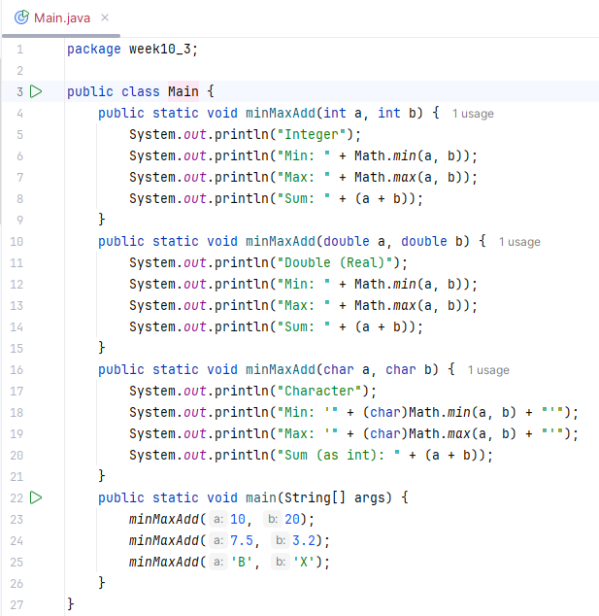
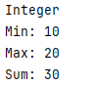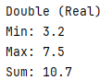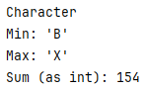
- Create a class ObjectOriented which has methods- abstraction(), polymorphism() and inheritance(). Create a class JavaLanguage which inherits from ObjectOriented class and has its own methods- persistence() and interfaces(). Create an object of JavaLanguage class to access all of its own and parent’s methods.
- In previous question, create a new class C++ which also inherits from ObjectOriented class and has its own methods- template() and friendFunction().Create an object of C++ class to access all of its own and parent’s methods.
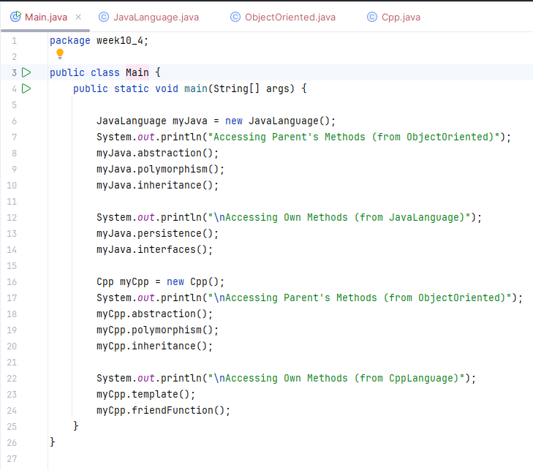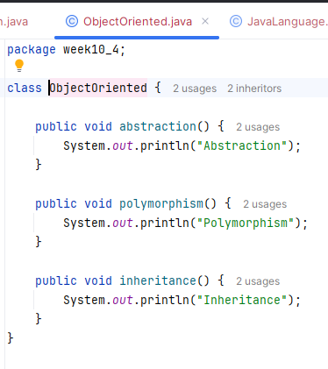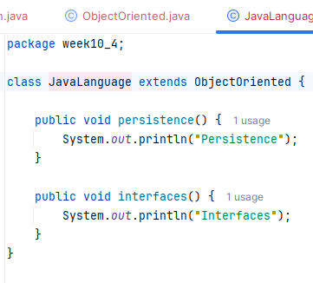
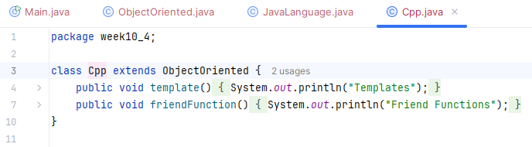
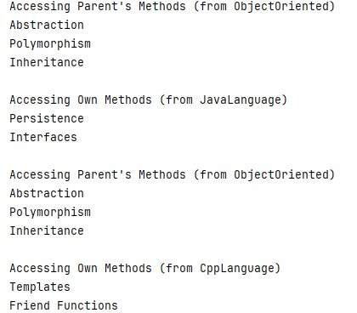
- Create class University which has data members- name and ranking. Create class Faculty that extends University class has data member- name and method- Details(). Create a new class Department which is derived from Faculty and has data member- name, chairman and method- Details() and Display() where Display() method calls Details() methods of both Faculty and Department class in its body. Create an object of Department class to Display() method and University ranking.
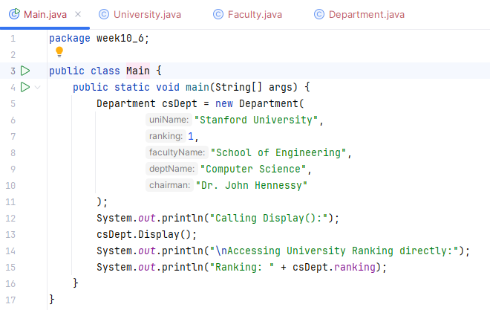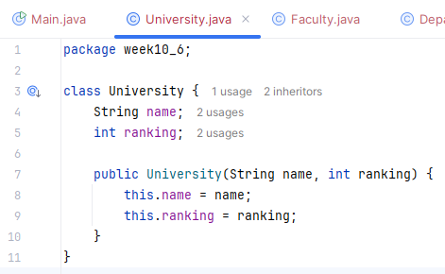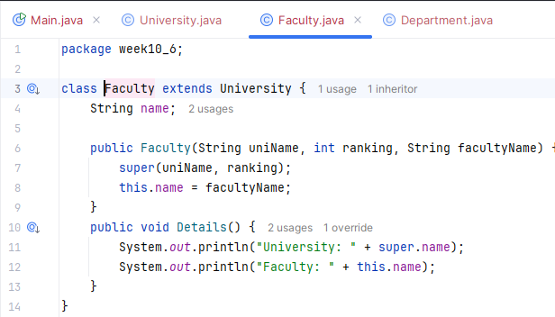
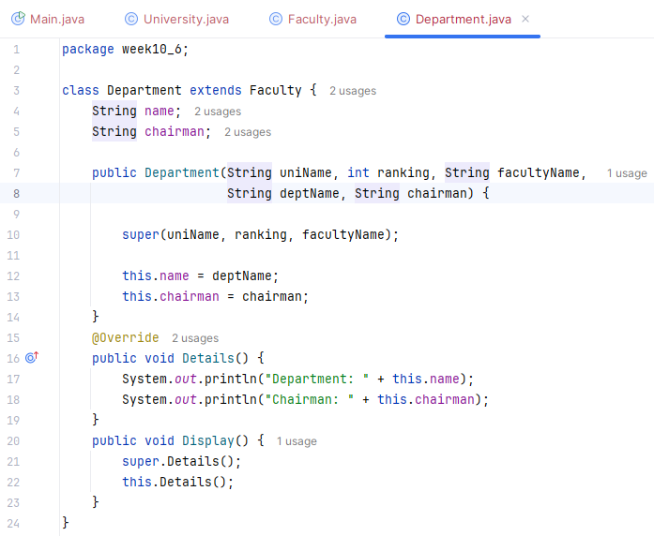

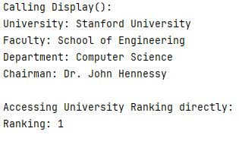
- Create a class Employee (Data Members – empName, empId). Create two member inner classes: ● Salary (Data Members – basic, hra, pf; Method – displaySalary() to print salary details) ● JoiningDate (Data Members – day, month, year; Method – displayJoiningDate() to print joining date). In the Employee class, create a method displayEmployee() that prints the employee’s name, ID, salary details, and joining date.
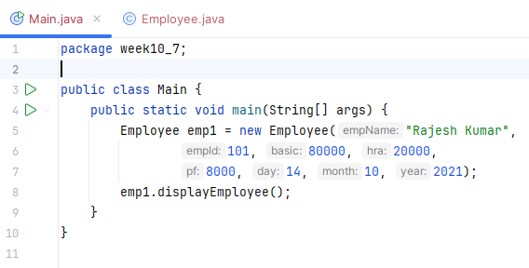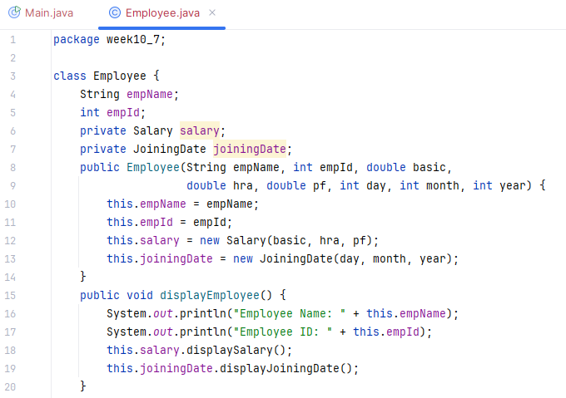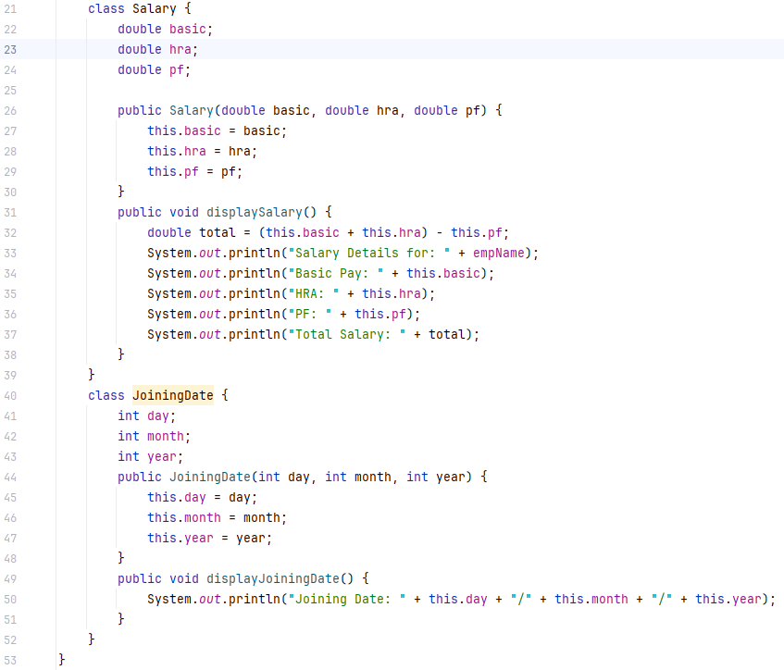
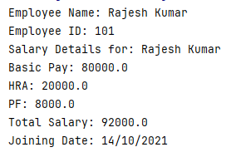
- Create a class Shape with overloaded methods area():
● area(int side)– calculates area of a square.
● area(int length, int breadth) – calculates area of a rectangle.
● area(double radius) – calculates area of a circle.
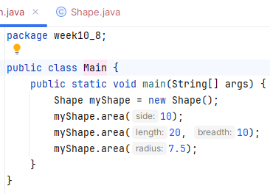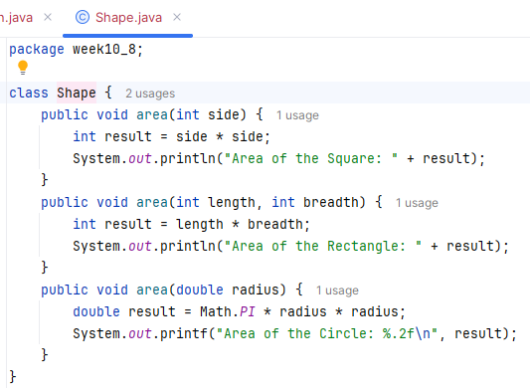

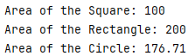
- Create a class Vehicle with a method run(). Create subclasses Bike and Car that override the run() method. In the main() method, use a reference of Vehicle to call run() for objects of Bike and Car.
